What CausesWind?
Wind is air in motion. Wind is caused by air flowing from high pressure to low pressure. Warm air rises because it weighs less than cold air. Then cool air moves in and replaces the rising warm air. This movement of air is what makes the wind blow.
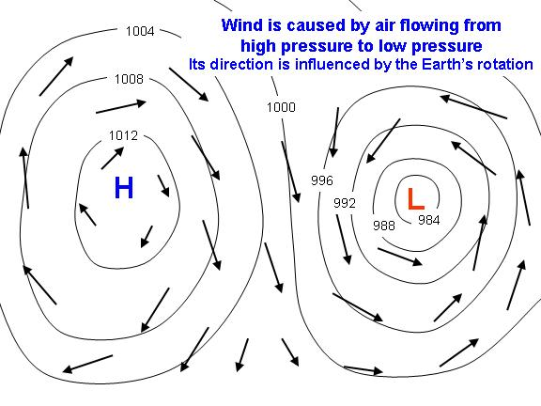
-----------------------------------------------
Wind is one way in which the atmosphere moves excess heat around. Wind helps to transport heat either away from the surface of the Earth, where sunlight causes an excess of energy buildup, or from warm regions (usually the tropics) to cooler regions (usually the higher latitudes).

